Project Design Phase-II

Data Flow Diagram & User Stories

|  |  |
| --- | --- |
| Date | 09 May 2023 |
| Team ID | NM2023TMID11342 |
| Project Name | COVID VISION: Advanced COVID-19  Detection from lung x-ray with Machine  learning or Deep learning |

# Data Flow Diagrams:

Data Flow Diagram (DFD) is a traditional visual representation of the information flows within a system. A neat and clear DFD can depict the right amount of the system requirement graphically. It shows how data enters and leaves the system, what changes the information, and where data is stored.

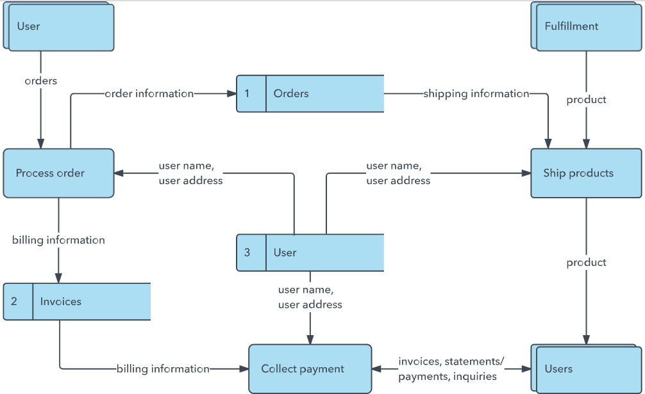

Example: DFD Level 0 (Industry Standard

re data is

# User Stories

|  |  |  |  |  |  |
| --- | --- | --- | --- | --- | --- |
| **User Type** | **Functional**  **Requirement (Epic)** | **User Story Number** | **User Story / Task** | **Acceptance criteria** | **Priority** |
| Investigator | Home page | USN-1 | As a user, I can access the home page and also predict page | I can access the home page after login | high |
|  | Predict page | USN-2 | As a user, I can upload images or video footages | I can access predict page to predict covid report images or  video footages | high |
|  |  | USN-3 | The respective identified report displayed for me | By processing the images or video footages the type of covid report will be predicted and corresponding output  will be displayed | high |
|  | Login | USN-4 | As a user, I can log into the web application by entering username & password | I can access login page using username and password |  |